Zach Patrignani

CSC 2110

Fall 2019

Test Plan

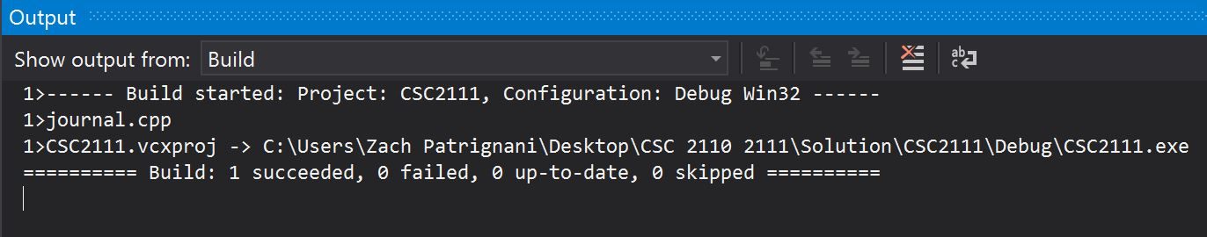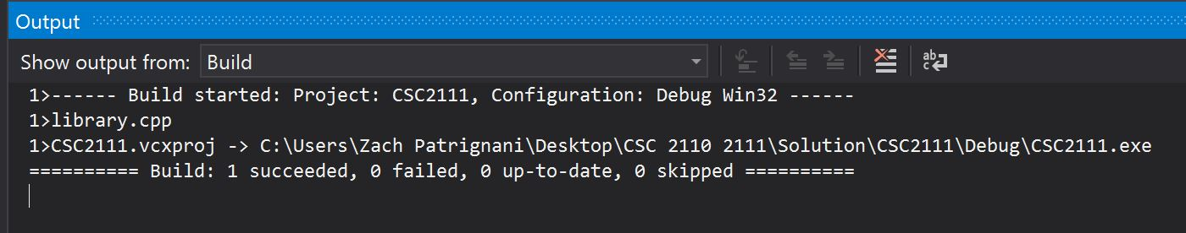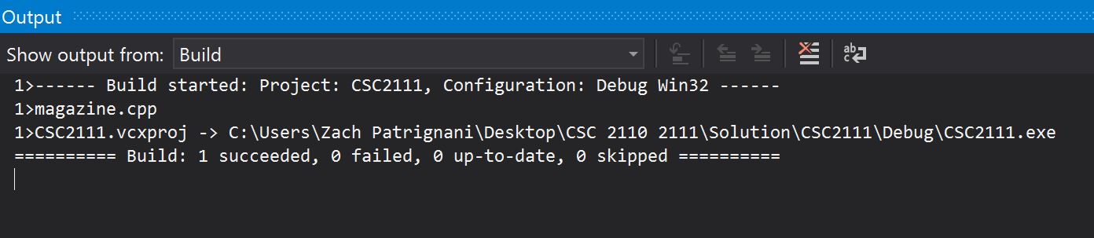The screenshots below show a successful build of the base class, main, and each of the derived classes. I made sure to build the program after I completed the base class first and proceeded to program a derived class. Once the first derived class built successfully, I knew that I could essentially copy and paste the derived class code into the other two derived classes.

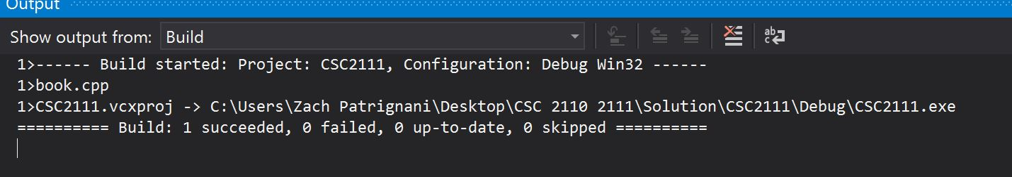

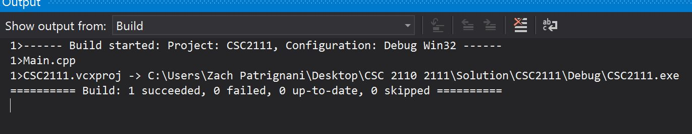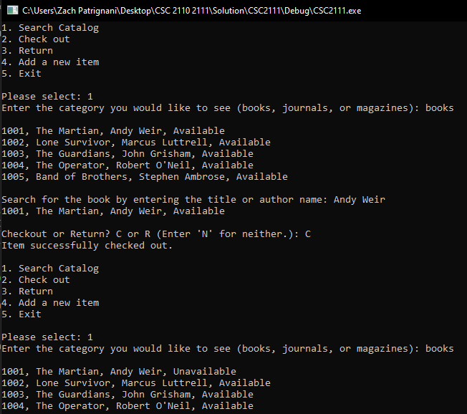

After ensuring that my program successfully built, I began to test whether my functions were correct. In the screenshot below, I searched the catalog for the books, which was successful as it printed out the books that I stored. I then tested my checkout function whose purpose was to change the status from “Available” to “Unavailable” to let the user know that the book is not available for checkout. This function also worked correctly, as you can see “The Martian” has a status of unavailable.

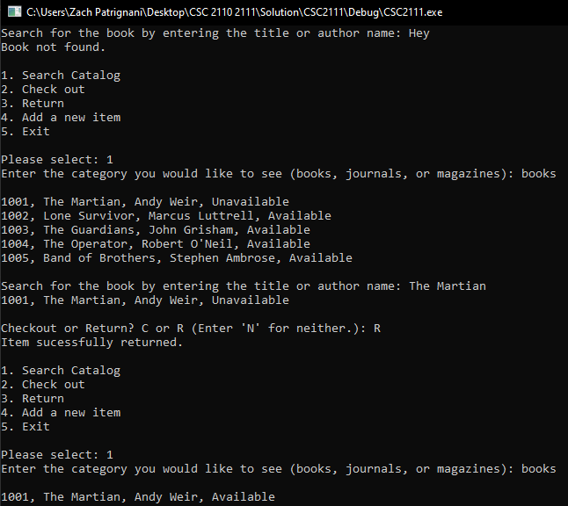In the screenshot below, I tested my error-handling of entering a title of a book not in the catalog. As you can see, I entered the title “Hey” and a message was outputted saying that the book was not found.

I then tested the method I used for searching for the books. If you look at the previous screenshot, you will see I searched for the book by the author, Andy Weir, which worked. Below, I searched for that same book, but by its title instead, which was successful. After this, I wanted to test my return function. The purpose of the return function was to change the status from “Unavailable” to “Available” which was successful.

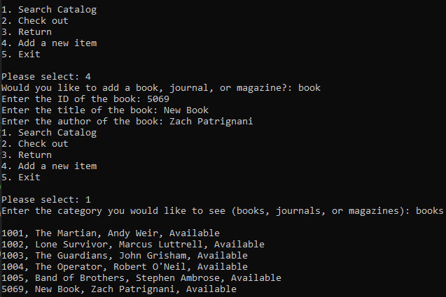Now that I know my search, checkout, return functions are correct, I moved to test my function that would add an item. I am first prompted to choose whether I want to add a book, journal, or magazine. I then enter the new book’s information, which is the ID, title, and author name. The prompt of author name changes to issue or volume for magazine or journal objects. Once I added the new book, I added it to the vector of book objects. To make sure it was added correctly, I select the books menu to print, which in the screenshot below prints the five books I originally stored, along with the book I had just added.

The only thing left to do at this point was to check my error-handling for the menu choice, which I did in the screenshot below. In this test plan, I only included the testing of the book objects, because as I said before the code for the magazines and journals are almost identical, just with different titles, issues, and volumes. 